Electrical Distribution System Grounding
Norbert Doerry
October 8, 2026
- Introduction
Onboard ship, electrical grounding refers to the practice of creating an electrical connection from an electrically conducting part, either directly with a conductor, or via an impedance, to the hull of the ship and the surrounding seawater. As detailed in IEEE Std. 45.3 and IEEE Std. 45.1, grounding is implemented for five different reasons:
a. Power system grounding to protect insulation systems on shipboard power system cabling, transformers, motors, generators, and other components.
b. Equipment grounding (protective earthing) for personnel safety implemented by bonding all exposed conductors together so that they are the same voltage.
c. Common mode grounding to provide a designed path for higher frequency common mode currents instead of through parasitic impedances. Typically implemented through Electromagnetic Interference (EMI) filters.
d. Cathodic protection to inhibit galvanic corrosion of the hull and other ship components.
e. Lightning protection to provide a designed path for lightning currents to pass through the ship’s hull to the water.
While this document focuses on the first two reasons, all of the grounding implementations interact with each other to some extent.
Shipboard power systems have historically been ungrounded. In an ungrounded power system, an electrical connection, either directly or via a power system component, between the power system conductors and the hull of the ship does not intentionally exist. The principal advantage of an ungrounded power system is that continued operation with a single line to ground fault is possible. A line to ground fault as an inadvertent electrical connection between a power system conductor and the hull of the ship; a ground fault typically occurs due to an insulation failure, component failure, flooding, or conducting debris. The principal disadvantages of an ungrounded power system are that electrical insulation must be thicker than for solidly grounded systems, and under certain intermittent ground fault conditions in ac systems, significant line to ground over-voltages may occur.
Terrestrial power systems typically are solidly grounded; the neutral conductor is solidly connected to ground. A ground fault results in very high fault currents that enable the traditional fault protection system (coordinated circuit breakers) to open the circuit breaker closest to the ground fault. In shipboard applications, having mission critical equipment trip offline during critical operations may not be ideal; the safety of the ship is likely to be more important than clearing the ground fault. Consequently, solidly grounded systems are typically not employed for portions of the power system supplying mission critical systems. On the other hand, some commercial off the shelf equipment (COTS) designed for operation with the terrestrial power system may not function, or function safely when connected to a power system that is not solidly grounded. Hence, it may be desirable for portions of the power system that supply non-mission critical systems to be solidly grounded.
High resistance grounding inserts a resistor between the power system neutral and ground. In ac systems, the value of the resistor is chosen to limit fault current such that the fault protection system does not automatically clear the fault; and such that transients are quickly damped during intermittent faults to preclude severe over-voltages. High resistance grounding is typically employed in ac systems with voltages about 1 kV and in some systems below 1 kV. In dc systems, the value of the resistor is chosen to be about an order of magnitude less than the design insulation resistance to keep the neutral voltage near the hull voltage should the insulation system have unbalanced conductor to ground resistances.
Each of the different grounding methods responds differently to line to ground faults and has different methods for locating and isolating the line to ground faults.
If a ground fault on one power system does not result in a change to the neutral to ground impedance of another power system, the two power systems are said to be separately derived systems. Separately derived systems are typically either totally disconnected from each other, or connected with a component that incorporates a transformer in the main power path. The grounding methods employed by two separately derived systems may or may not be the same.
For further information on shipboard power system grounding, see Doerry, Islam, and Prousalidis (2025), IEEE Std. 45.1, and IEEE Std. 45.3. For power system grounding in general, see IEEE Std 3003.1.
- System grounding
  - Ungrounded systems
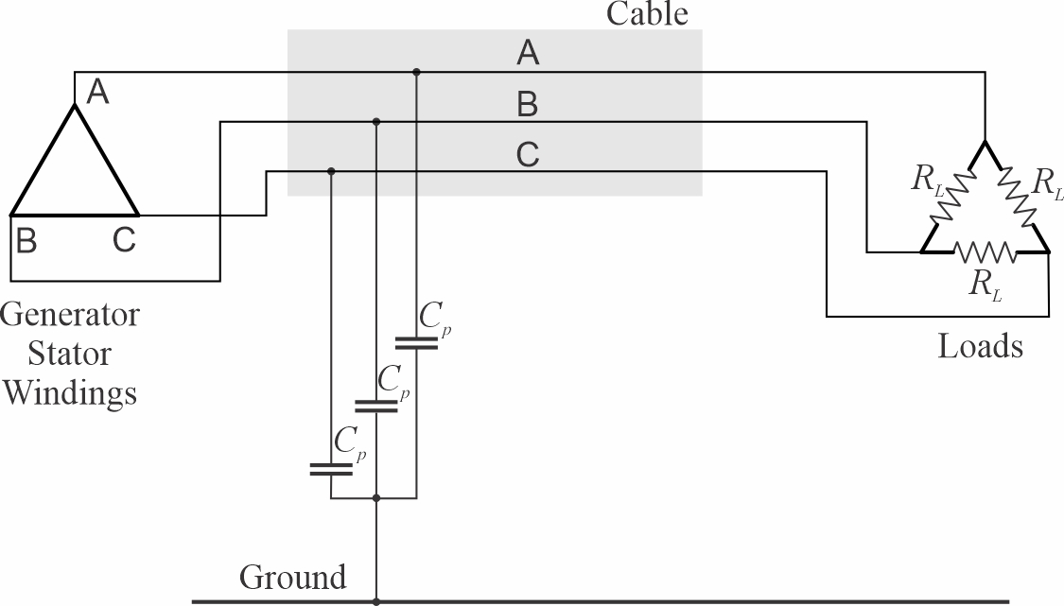
Figure 1: Ungrounded Power System
Figure 1 depicts an ungrounded power system. Although there are no intentional connections between the power system conductors and ground, parasitic capacitances (C_{p}) between the conductors and ground make the system effectively capacitively grounded. The capacitance is largely due to line to ground capacitance of the cable conductors and line to ground capacitances within EMI filters. Since the parasitic capacitances are typically equal for each phase, the sum of the currents through the parasitic capacitances is zero when the system is not faulted.
Doerry, Islam and Prousalidis (2025) provide guidance for estimating the value of the parasitic capacitance.
In an ungrounded system, generator stator windings are typically connected as delta windings (as shown in Figure 1). Likewise, loads are usually connected as delta loads.
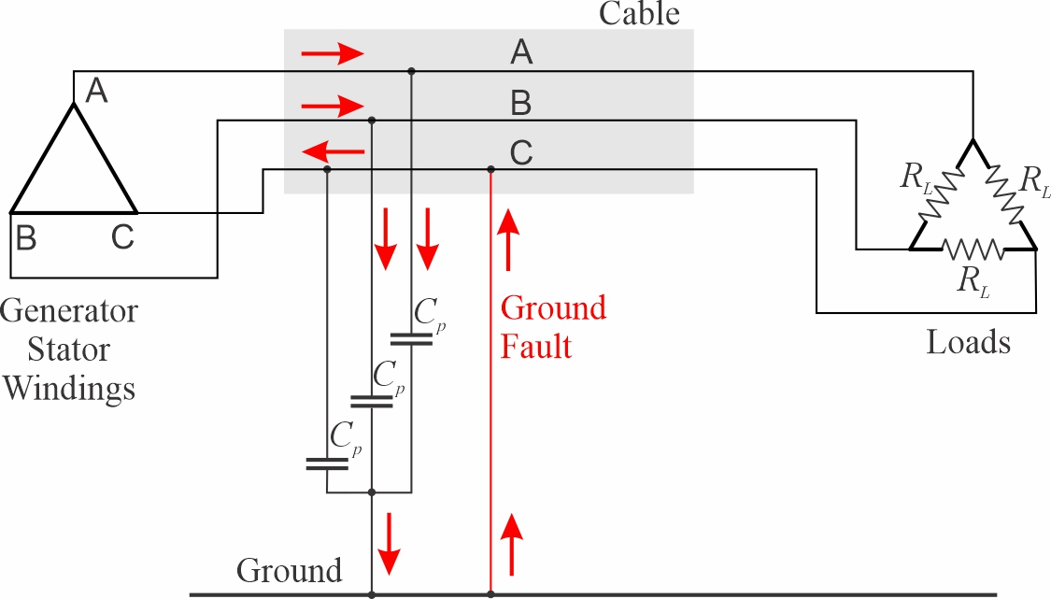
Figure 2: Current path during ground fault on an ungrounded system.
Figure 2 depicts the current path during a ground fault on an ungrounded system. The ground fault current starts in the unfaulted phases, flows through the parasitic capacitances, up through the ground fault, and returns to the faulted phase. The magnitude of the ground fault current is determined by the line to line (or line to neutral) voltage and the magnitude of the parasitic capacitance.
$\left|i_{fault}\right|=\left(3ωC_{p}\right)\frac{V_{line_to_line}}{\sqrt{3}}=\left(3ωC_{p}\right)V_{line_to_neutral}$ [1]
In ungrounded shipboard power systems, ground fault currents can be expected to have magnitudes in the amps to tens of amps.
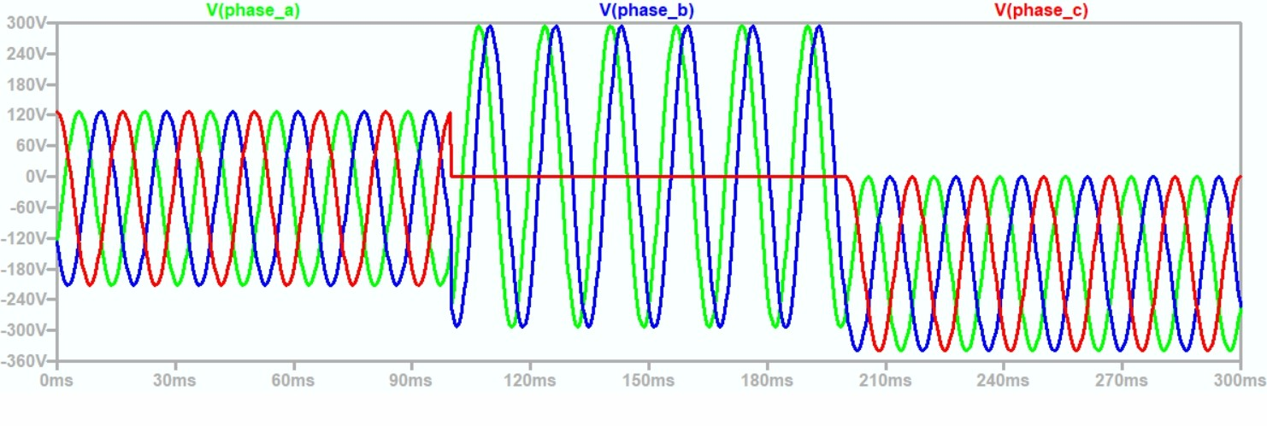
Figure 3: Line to ground voltages for ungrounded system during ground fault (20251117 ungrounded.asc)
Figure 3 depicts the line to ground voltages before, during, and after a ground fault on an ungrounded system. Prior to the ground fault, the line to ground voltages are centered around ground (0 volts). During the ground fault, the line to ground voltage on the faulted phase is zero, and the remaining two unfaulted phases have a line to ground voltage equal to the line-to-line voltage in magnitude and 60 electrical degrees apart. Once the fault clears, the line to ground voltages of all phases have the same shape as the unfaulted condition, but with a dc offset. The dc offset is due to trapped charge in the parasitic capacitance when the fault clears. Over time, this dc offset will decay to zero.
Other than possibly very fast transients (not modelled in the simplified circuit used to generate Figure 3), the line-to-line and line-to-neutral voltages are not impacted by the ground fault. Similarly, the current into the load is also not impacted by the ground fault. The lack of impact to the line-to-line voltages and line currents during a ground fault is one of the key reasons ungrounded systems have been used onboard ships.
One drawback to ungrounded systems is the need for the insulation system to be rated for the line-to-line voltage rather than the line-to-ground voltage requirement for solidly grounded systems. Another drawback is that under very specific conditions, an intermittent ground fault that restrikes once or twice per cycle can result is transient voltages with magnitudes several times the nominal line-to-neutral voltage.
  - High resistance grounded systems
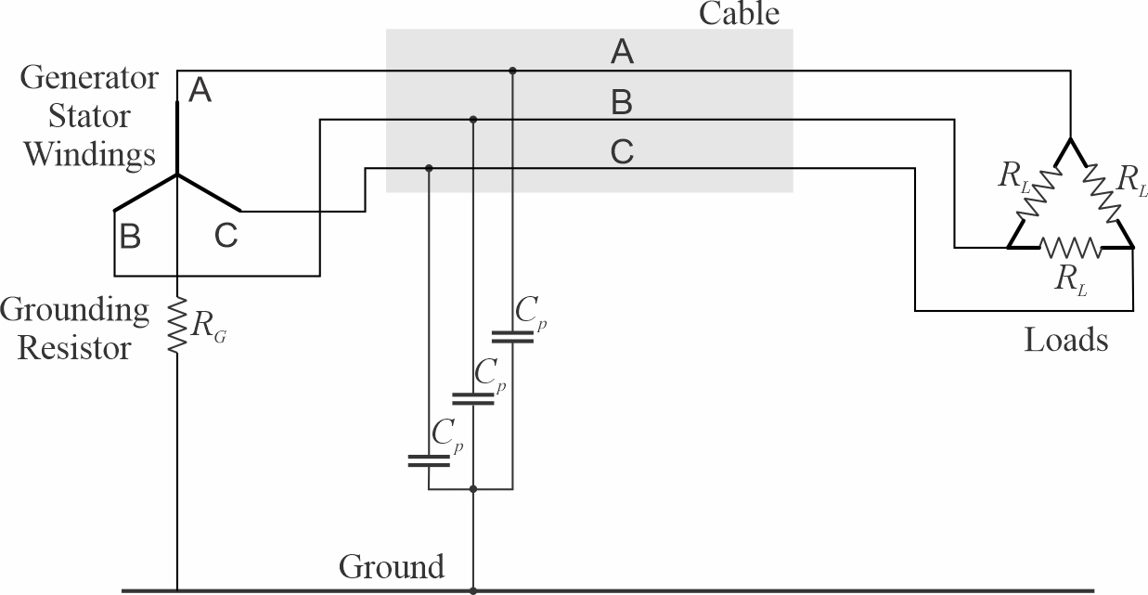
Figure 4: High resistance grounded power system
Figure 4 depicts a high resistance grounded power system. While a wye-connected generator is depicted, a delta connected generator may be employed if an additional grounding transformer is used to establish a neutral conductor (see section 2.4.1). The grounding resistor connects the wye connection point of the generator stator windings to ground. The grounding resistor value is high enough so that if a ground fault is present, the magnitude of the ground fault current is low enough to not cause a circuit breaker to trip. The grounding resistor value is low enough to dampen out transients during intermittent ground faults to preclude damaging transient over voltages. The ground resistance is normally chosen to nearly equal the impedance of the paralleled parasitic capacitances as shown in [2].
$R_{G}≈\frac{1}{3ωC_{p}}$ [2]
The resulting RC time constant ($τ)$ that determines how fast transients decay is given by [3] and [4]. Equation [4] shows that in one period (T) of the voltage waveform, transients will have experienced over six time constants of decay. In one half of T, transients will have experienced over three time constants of decay. Transients from an intermittent ground fault will likely have decayed to less than 5% of their original value between ground faults.
$τ=3C_{p}R_{G}≈\frac{1}{ω}=\frac{1}{2π}T$ [3]
$T≈ 2πτ$ [4]
If the grounding resistor value is chosen per [2], then the ground fault current will be the sum of the currents through the parasitic capacitances and the grounding resistor; these two currents have the same magnitude, but are 90 electrical degrees out of phase. Hence the ground fault current is $\sqrt{2}$ times what the ground fault current would be in an ungrounded system as shown in [5].
$\left|i_{fault}\right|=\frac{V_{line_to_line}}{\sqrt{3}}\sqrt{{\left(3ωC_{p}\right)}^{2}+{\left(\frac{1}{R_{G}}\right)}^{2}}≈\sqrt{2}\left(\frac{V_{line_to_line}}{\sqrt{3}}\right)\left(3ωC_{p}\right)$ [5]
Figure 5 depicts the line to ground voltages before, during, and after a ground fault on a high resistance grounded system. The waveforms before and during the ground fault are nearly identical to the ungrounded case. Once the ground fault clears however, the trapped charge causing the dc offset in the ungrounded case is quickly dissipated by the grounding resistor; the voltage waveforms return to their pre-faulted states within a cycle after the ground fault clears.
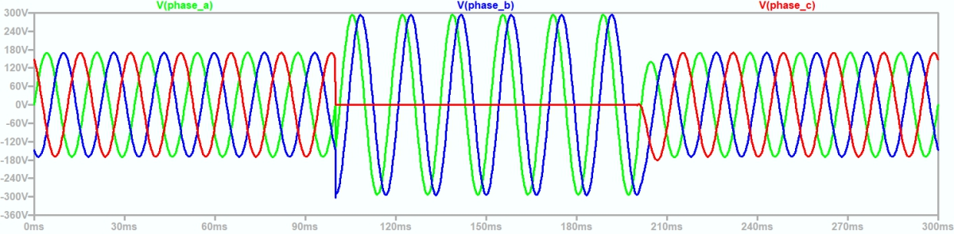
Figure 5: Line to ground voltages for high resistance grounded system during ground fault (20251118 hrg - 1.asc)
  - Solidly grounded systems
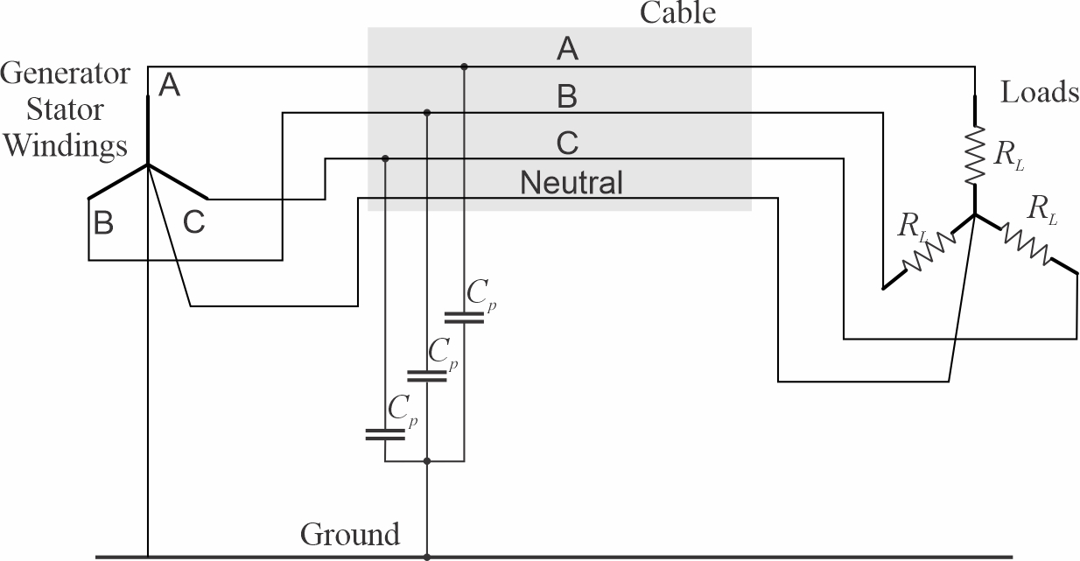
Figure 6: Solidly grounded power system
Figure 6 depicts a 4-wire solidly grounded system. In addition to the three phase conductors, a neutral conductor connects the wye connection point of the wye connected loads and the wye connection point of generator stator windings. The wye connection point of the generator is solidly connected to ground. Although not depicted, four wire systems can also have higher voltage loads connected between phases.
One advantage of solidly grounded systems is that line to neutral loads only require line to ground insulation systems rated for the line-to-neutral voltage and not line-to-line voltage as required by the other grounding systems. Another advantage is that solidly grounded systems are used in terrestrial power systems; commercial equipment is generally designed to work with solidly grounded systems. Commercial equipment should be tested before installation in an ungrounded or high resistance grounded system to ensure proper operation.
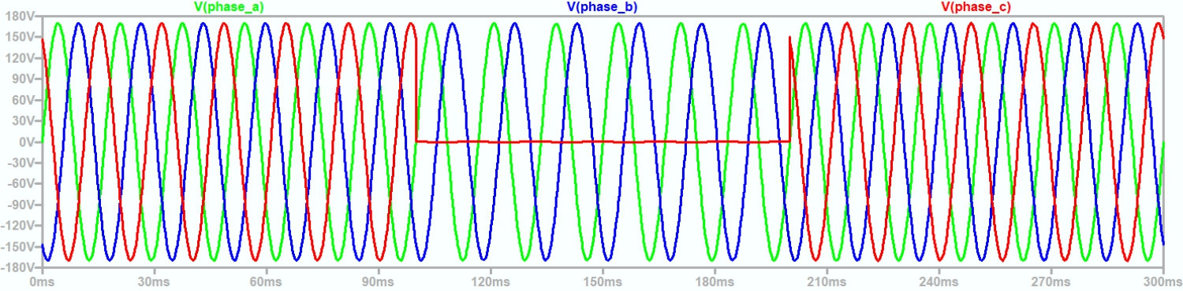
Figure 7: Line to ground voltages for solidly grounded system during ground fault (20251118 solid - 1.asc)
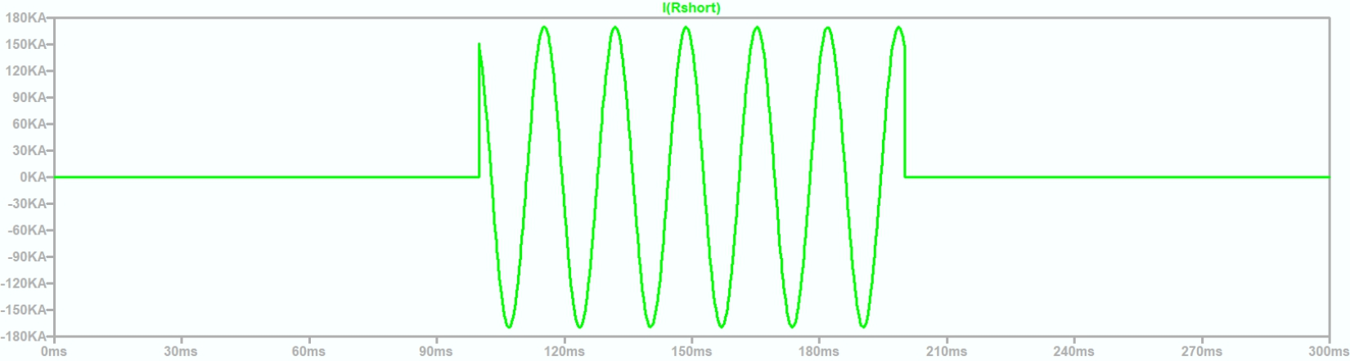
Figure 8: Fault current for solidly grounded system during ground fault (20251118 solid - 1.asc)
Figure 7 depicts the line to ground voltages for a solidly grounded system before, during, and after a ground fault. During the ground fault, the line to ground voltage of the faulted phase is zero as expected. The wye connected loads connected to the faulted phase experience a power interruption. The ground fault current is very high as shown in Figure 8. The magnitude of the fault current is determined by generator and cable impedances. In any case, the fault current magnitude is sufficiently high to trip the appropriate circuit breakers.
  - Grounding equipment
    - Grounding transformer
The purpose of a grounding transformer is to provide two electrical terminals where the voltage between the terminals is the neutral voltage, or proportional to the neutral voltage of a three-phase power system with respect to ground. A grounding resistor is usually connected between these two terminals.
      - Zigzag transformer
Figure 9 depicts a zigzag transformer. This transformer may be fabricated from three single phase transformers, or from a single three phase transformers. The turns ratio between the primary and secondary windings is equal to 1. The equations for this transformer are given by:
$v_{an}=v_{a}-v_{n}=v_{1}-v_{2}$ [6a]
$v_{bn}=v_{b}-v_{n}=v_{2}-v_{3}$ [6b]
$v_{cn}=v_{c}-v_{n}=v_{3}-v_{1}$ [6c]
Combining …
$\left(v_{a}-v_{n}\right)+\left(v_{b}-v_{n}\right)+\left(v_{c}-v_{n}\right)=0$ [7]
This implies that $v_{n}$ is the neutral voltage; it is the voltage reference for which the sum of the phase voltages is zero. Furthermore, since the primary of one phase is connected to the secondary of another phase, the two phase currents, and by extension, all three phase currents are equal. The sum of these three phase currents (i_{n}) is by definition a common mode current.
Under normal conditions when there is not a ground fault or a source of common mode current flowing to ground, i_{n} is equal to zero. Consequently, under normal conditions, there is no voltage drop across R_{G} and v_{n} is also 0.
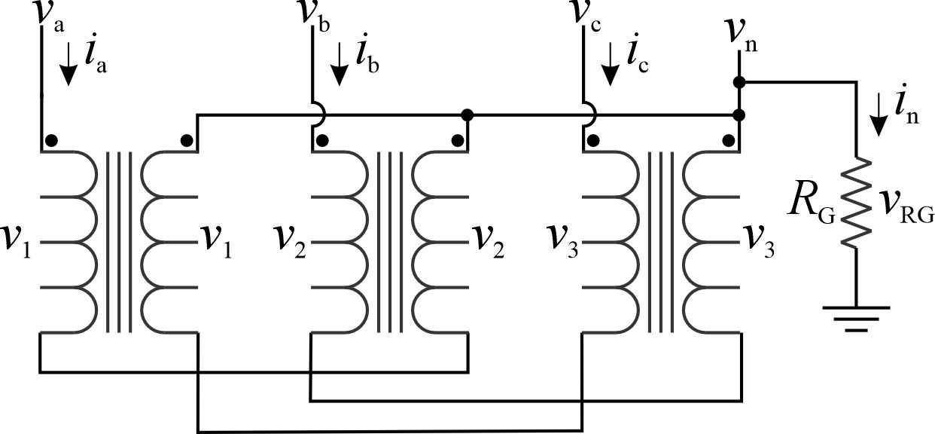
Figure 9: Zig-zag grounding transformer
Under balanced three phase operation …
$v_{ab}=v_{a}-v_{b}=V_{ll}\cos\left(ωt\right)$ [8a]
$v_{bc}=v_{b}-v_{c}=V_{ll}\cos\left(ωt-\frac{2}{3}π\right)$ [8b]
$v_{ca}=v_{c}-v_{a}=V_{ll}\cos\left(ωt+\frac{2}{3}π\right)$ [8c]
If phase a is grounded then:
$v_{a}=0$ [9a]
$v_{b}=v_{a}-v_{ab}={-v}_{ll}\cos\left(ωt\right)=V_{ll}\cos\left(ωt+π\right)$ [9b]
$v_{c}=v_{a}+v_{ca}=V_{ll}\cos\left(ωt+\frac{2}{3}π\right)$ [9c]
Note the two unfaulted phases ($v_{b} \text{and} v_{c}$) are out of phase by $\frac{π}{6}$ radians or 60° as is depicted in Figure 5.
During the ground fault, the neutral voltage with respect to ground was initially 0. By setting phase a to zero, the neutral voltage shifts by $-v_{a}$.
$v_{n}=V_{RG}=-v_{a}$ [10]
The current through the grounding resistor is thus:
$i_{n}=\frac{-v_{a}}{R_{G}}$ [11]
Zigzag transformers are commonly found on low voltage systems; at medium voltage instrumentation must be rated for medium voltage.
      - Wye-delta transformer
Figure 10 depicts a delta-wye grounding transformer. This transformer may be fabricated from three single phase transformers, or from a single three phase transformers. While the turns ratio as shown between the primary and secondary windings is equal to 1, a different turns ratio may be employed. The equations for this transformer are given by:
$i_{s}=i_{a}=i_{b}=i_{c}$ [12]
$i_{n}=i_{a}+i_{b}+i_{c}={3i}_{s}$ [13]
Since the common-mode current is the sum of the phase currents:
$i_{CM}=i_{n}={3i}_{s}$ [14]
$v_{n}=i_{n}R_{G}$ [15]
From the secondary voltages
$v_{1}+v_{2}+v_{3}=0$ [16]
or
$\left(v_{a}-v_{n}\right)+\left(v_{b}-v_{n}\right)+\left(v_{c}-v_{n}\right)=0$ [17]
$v_{n}$ is therefore the neutral voltage and the current through the grounding resistor is the common mode current.
Wye-delta transformers are commonly found on low voltage systems; at medium voltage instrumentation on the grounding resistor must be rated for medium voltage.
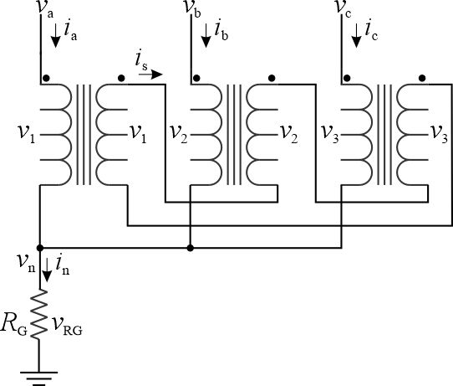
Figure 10: Wye-delta grounding transformer
      - Wye-broken delta transformer
Figure 11 depicts a delta-wye grounding transformer. This transformer may be fabricated from three single phase transformers, or from a single shell-type three phase transformer. A core-type three phase transformer will not work. While the turns ratio as shown between the primary and secondary windings is equal to 1, a different turns ratio may be employed. The equations for this transformer are given by:
$v_{a}= v_{1} v_{b}= v_{2} v_{c}= v_{3}$ [18]
${v_{RG}=v}_{1}+v_{2}+v_{3}= i_{s}R_{G}$ [19]
$\frac{v_{1}+v_{2}+v_{3}}{3}=\frac{v_{RG}}{3}=v_{n}$ [20]
$i_{s}=i_{a}=i_{b}=i_{c}$ [21]
$i_{CM}=i_{a}+i_{b}+i_{c}={3i}_{s}=3\frac{v_{RG}}{R_{G}}=9\frac{v_{n}}{R_{G}}$ [22]
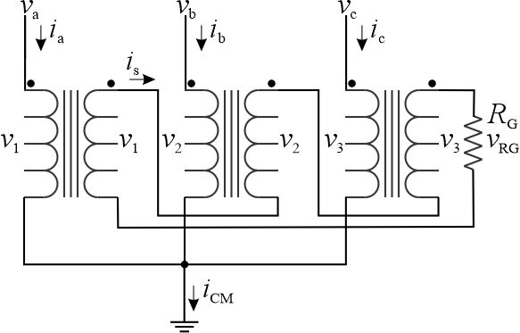
Figure 11: Wye-broken delta grounding transformer
Wye-delta transformers are commonly found on medium voltage systems; with an appropriate turns ration, the voltages on the secondary can be low voltage to enable the use of low voltage sensors.
    - Grounding resistor
Grounding resistors are usually wire wound resistors. Ideally, they should be able to handle their power rating continuously; otherwise, the motivation for employing a high resistance grounded system is undermined. The minimum power rating (P_{GR}) of the grounding resistor is given by:
$$P_{GR}=\frac{V_{ll}I_{Gmax}}{\sqrt{3}}$$
Where:
V_{ll} = line-to-line rms voltage (nominal system voltage)
I_{Gmax} = maximum grounding resistor rms current
The heat (power) that must be dissipated by the grounding resistor is depicted in Table I for several values of grounding resistor current. For low voltage systems (below 1 kV), the amount of power is generally low enough such that forced air cooling is likely sufficient. For medium voltage systems (above 1 kV), the design of the cooling system to handle the high amount of heat becomes more challenging. Water cooling is one option.
Table I: Grounding resistor power dissipation (Three-phase power system)
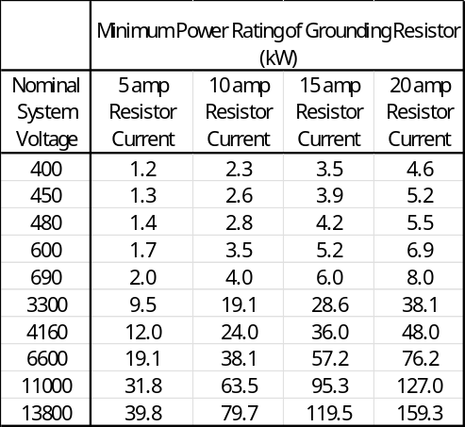
Grounding resistors are typically instrumented to measure the voltage across them, the current through them, and sometimes, their temperature. The cooling system may also be instrumented. Additional circuitry may be included to assist with fault detection and localization.
    - Grounding bus
46 CFR 111.05-13 states:
“Each grounded system must have only one point of connection to ground regardless of the number of power sources operating in parallel in the system.”
This requirement is appropriate for solidly grounded systems where multiple points of connection could result in hull currents under normal conditions. The rationale for this requirement in high resistance grounded system is not clear. Doerry, Islam, and Prousalidis (2025) demonstrate why for most systems, multiple points of connection in high resistance grounded systems do not result in significant hull currents.
Traditionally, grounding transformers and resistors are located at the generator switchboards as shown in Figure 12. Each grounding resistor has a switch; each set of paralleled generators is operated such that exactly one grounding resistor connected to ground via its switch. The grounding resistor switch is instrumented to indicate its position and the current flowing through it. The grounding resistor has the value specified by equation [2] where the parasitic capacitance is for the entire ship. The power the grounding resistor must dissipate is likely to correspond to the 10 amp or 15 amp column of Table I. For medium voltage systems, special cooling is likely required.
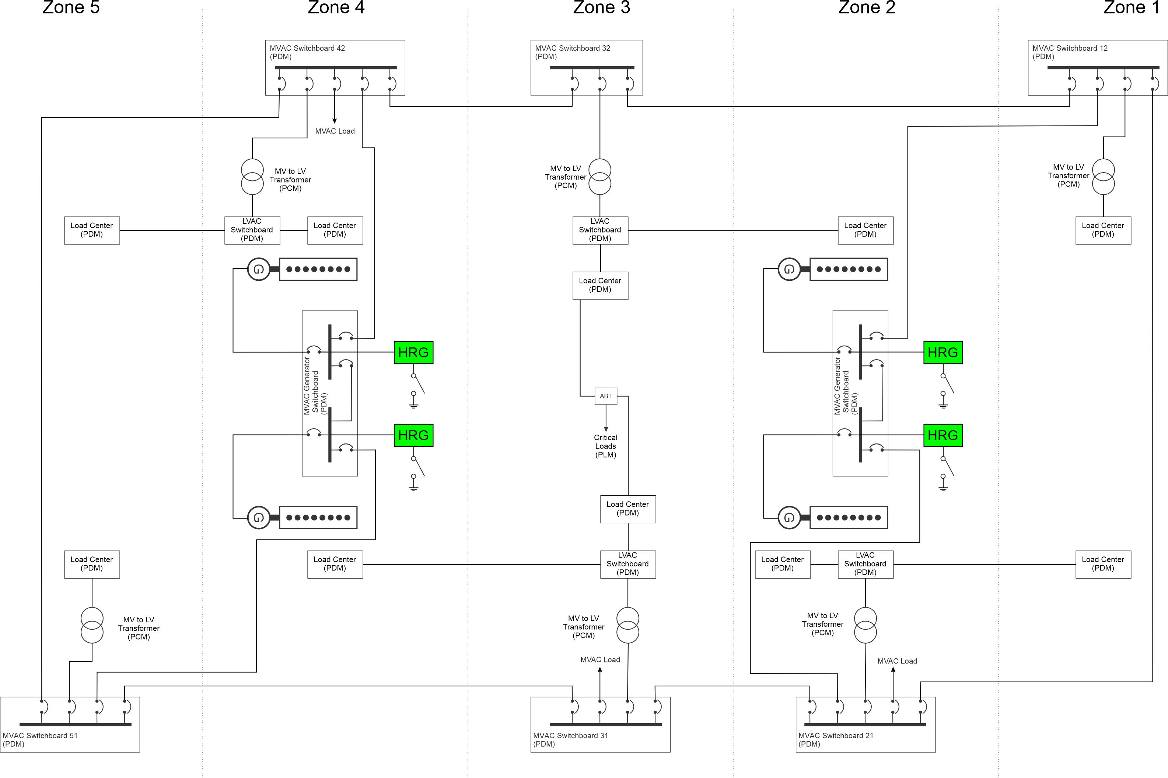
Figure 12: Grounding resistors at generator switchboards
Figure 13 depicts an alternate method of employing high resistance grounding. It does not however, comply with 46 CFR 111.05-13. Each zonal switchboard has its own grounding transformer and resistor; the grounding resistor is permanently connected to ground. One advantage of this approach is that each grounding resistor is sized only for the line-to-ground parasitic capacitance of the loads directly connected to it and of the bus-tie cables connected to it. The amount of power each resistor is required to dissipate under a ground fault is much reduced, thereby simplifying the resistor cooling system.
Figure 14 preserves the advantage of locating the grounding resistors with the zonal switchboard while simultaneously providing only a single point of connection to ground. The grounding resistors are all directly connected to a grounding bus; shown as a ring bus in Figure 14. The ring bus has two switches to ground, one each in zones 1 and 5; normally one switch is closed and the other open. The same switch may be left closed indefinitely. The other switch is only used as a backup if the ring bus is damaged and broken in two locations.
A grounding bus may also be employed in ships with non-metallic hulls to provide a path to the grounding plate mounted on the exterior of the hull. See section 4.
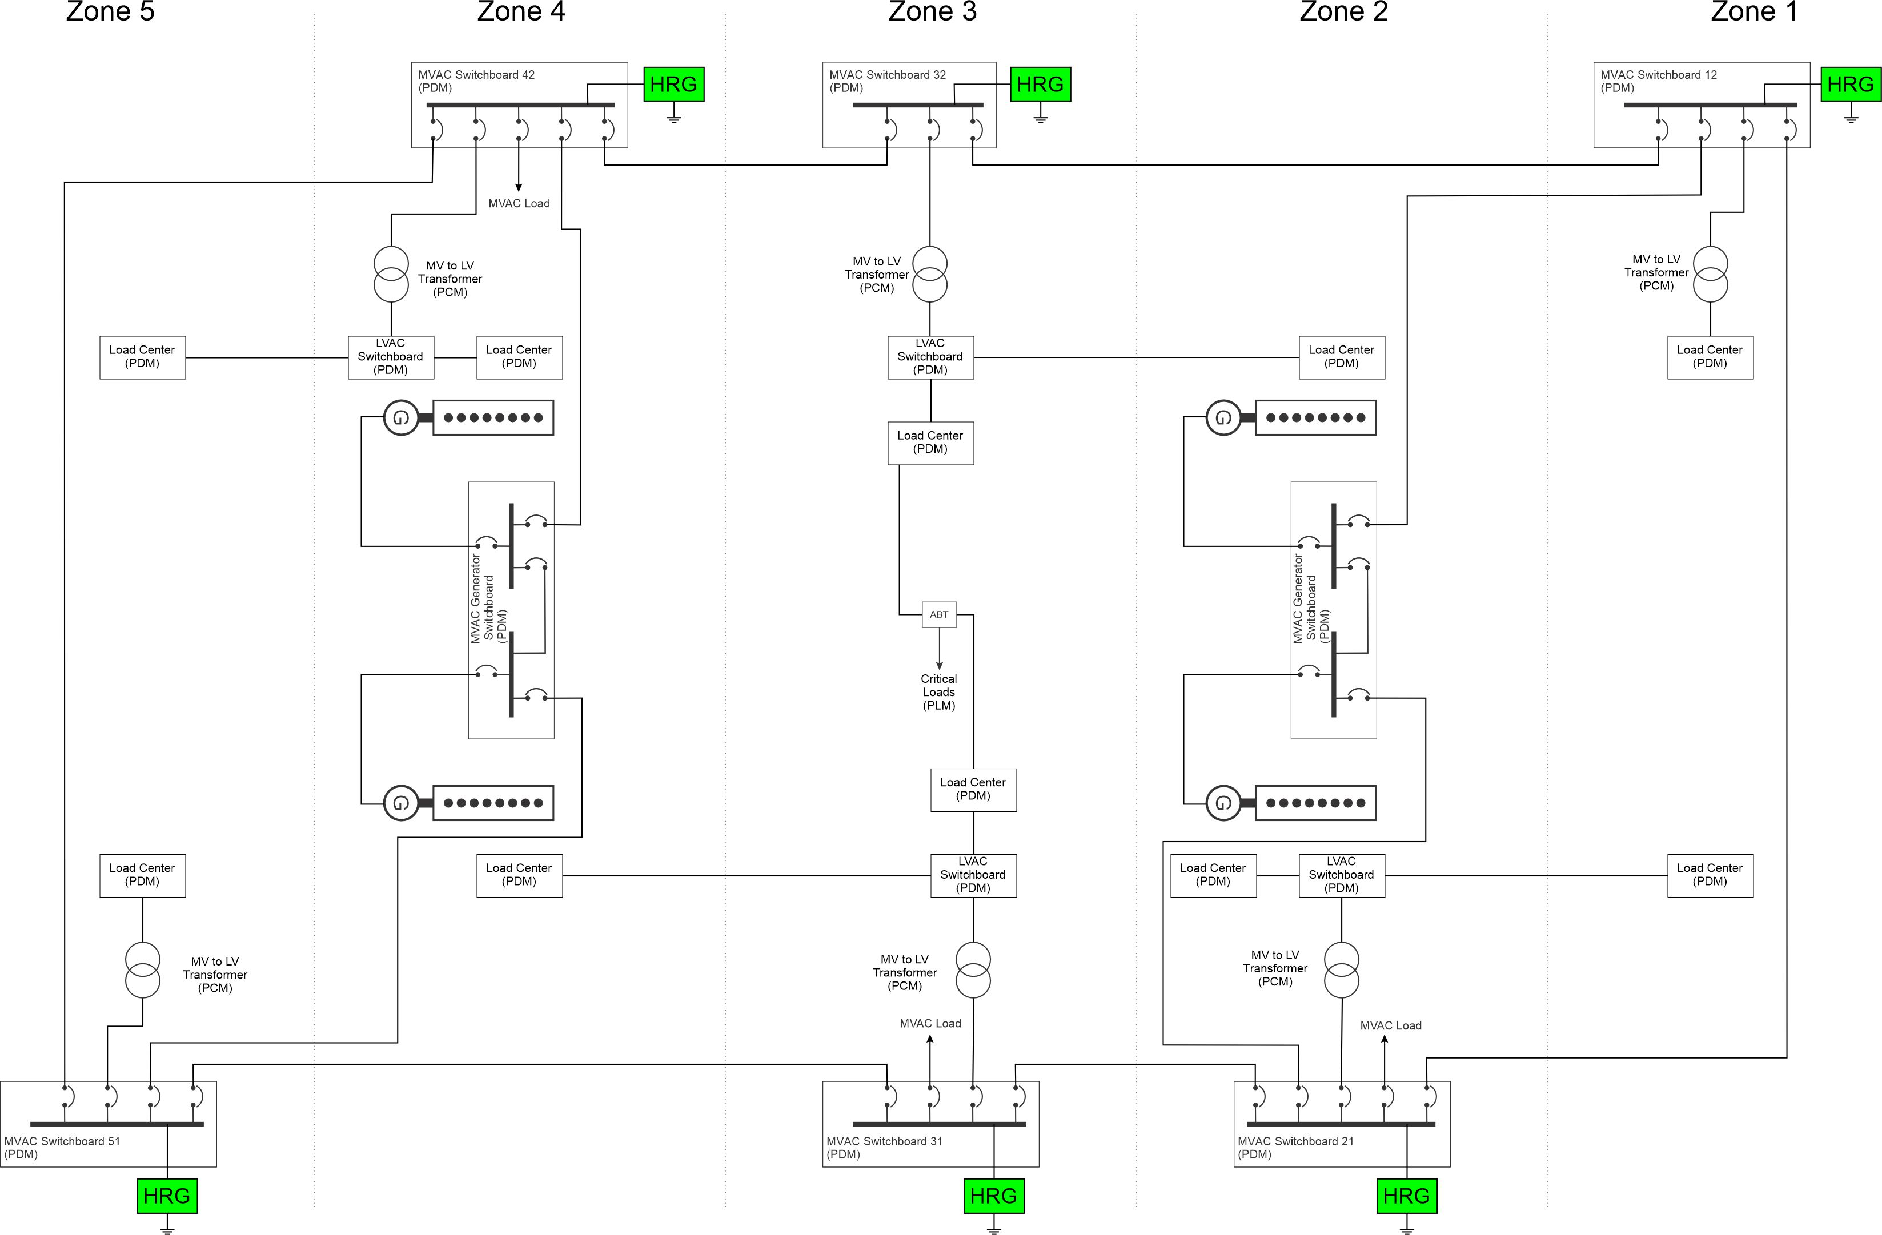
Figure 13: Grounding resistors at zonal switchboards
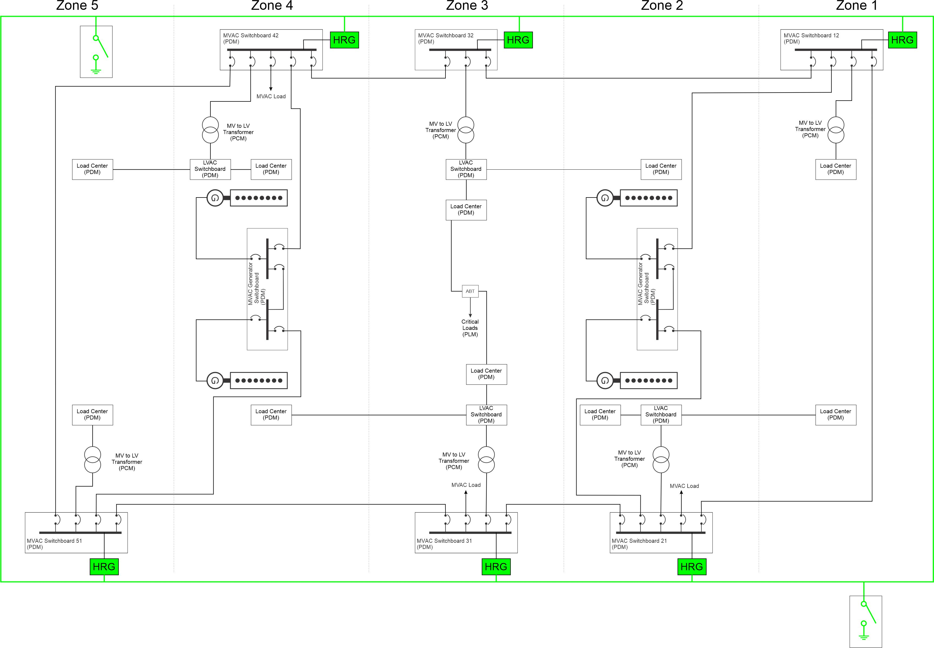
Figure 14: Grounding resistors at zonal switchboards with grounding bus
  - Application
    - Primary bus
As detailed in IEEE Std 45.1, primary buses should employ a high resistance grounded system.
    - Distribution bus
As detailed in IEEE Std 45.1, distribution buses should employ either a high-resistance grounded or an ungrounded system.
    - Secondary bus
As detailed in IEEE Std 45.1, secondary buses powering critical loads should be either a high-resistance grounded or an ungrounded system. Secondary buses powering non-critical buses should be solidly grounded.
    - Special bus
As detailed in IEEE Std 45.1, special buses such as those servicing hospital facilities may require special grounding treatment. Emergency power buses should have the same grounding system as the distribution bus they connect to.
- Bonding and protective earthing
The terms bonding, protective earthing, equipment earthing, and equipment grounding all refer to the act of connecting exposed metal parts that are not designed to conduct electricity under normal conditions to ground (ship’s hull or sea water) via a low-impedance path. Figure 15 depicts the equipment grounding connection on a 120 V ac outlet. Should an energized conductor (such as the “hot” black insulated conductor) come in contact with the exposed metal part, a large current should flow and cause the circuit breaker to trip. Furthermore, since the exposed metal part has a low impedance connection to ground, the voltage to ground is ideally less than the safe touch voltage of about 40 volts; this should prevent electrocution of anyone who touches the exposed metal part.
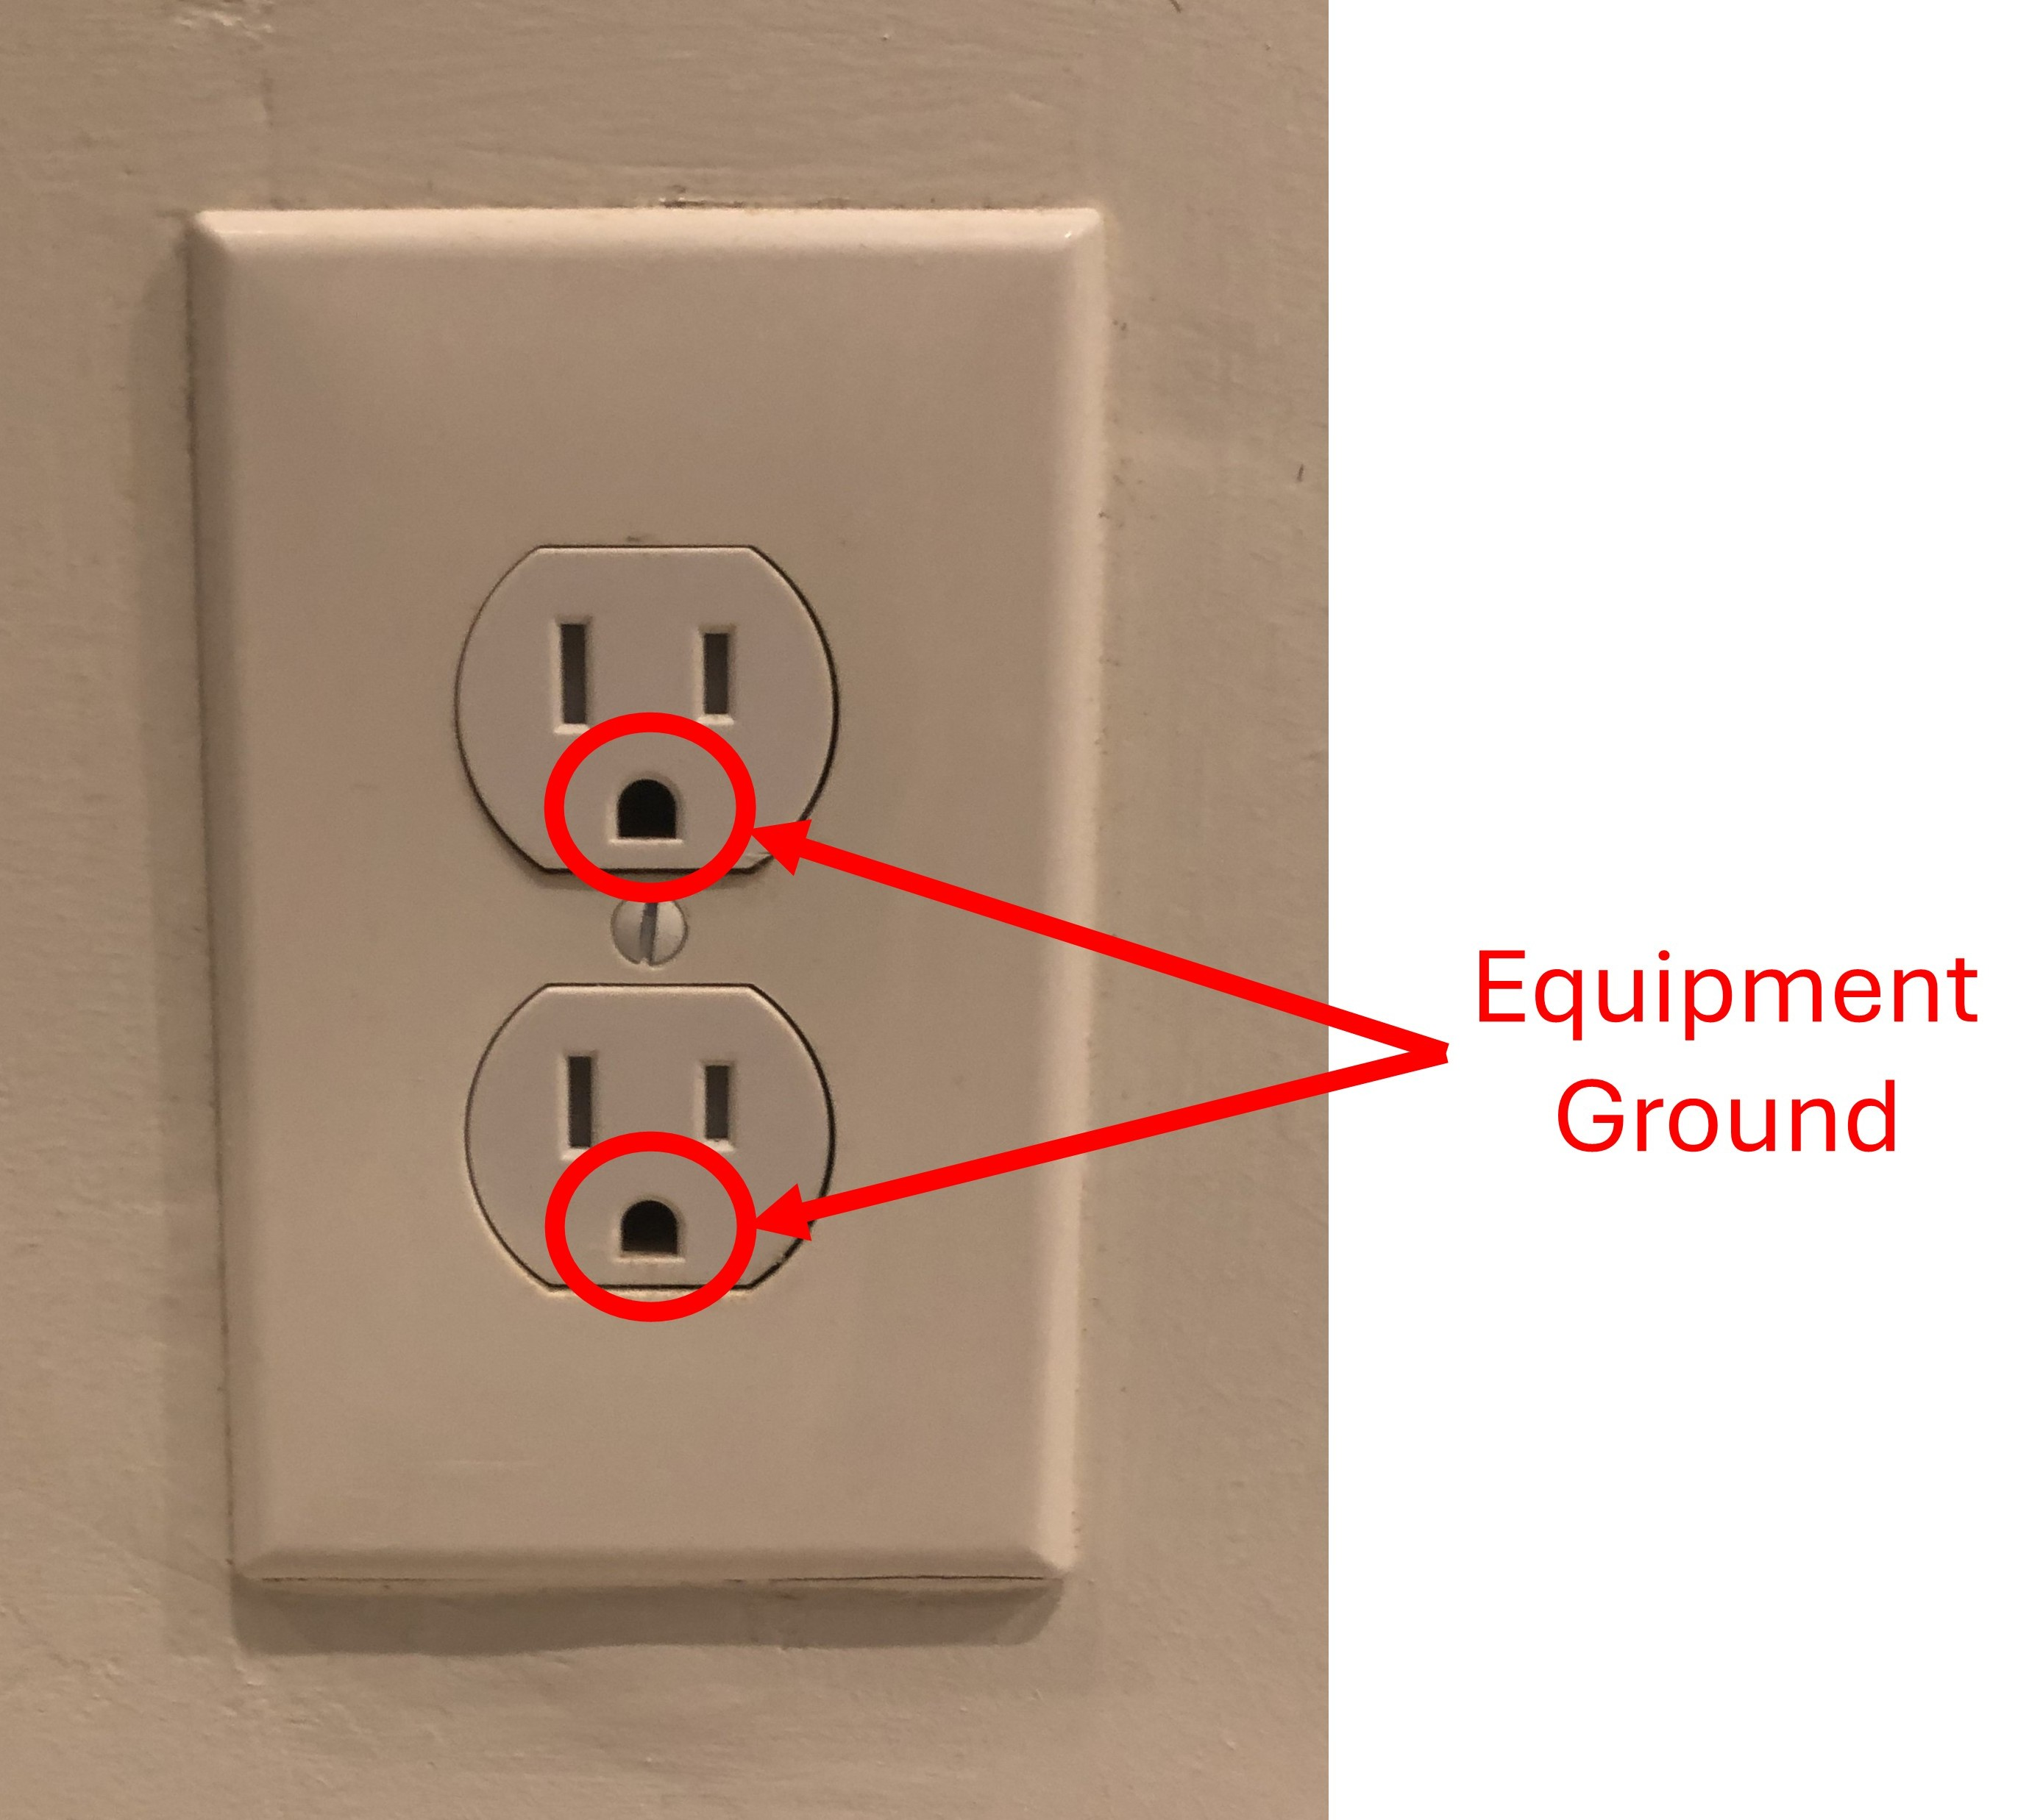
Figure 15: Equipment ground on 120 V receptacle. (Photo by Norbert Doerry, Licensed CC BY 4.0)
Onboard a metallic hull ship, the low-impedance path is usually through the hull of the ship; a grounding / bonding strap as depicted in Figure 16 is used to connect exposed metal parts to the hull of the ship.
Bonding also plays a role in limiting Electromagnetic Interference (EMI) by providing a path for induced currents to ground. Grounding / bonding straps as depicted in Figure 16 may be installed to provide such a path.
MIL-STD-1310 is a good reference for shipboard grounding / bonding. MIL-STD-2003-2 provides additional guidance for implementing MIL-STD-1310; Figure 17 and Figure 18 are examples of bonding techniques for equipment installed onboard ship.
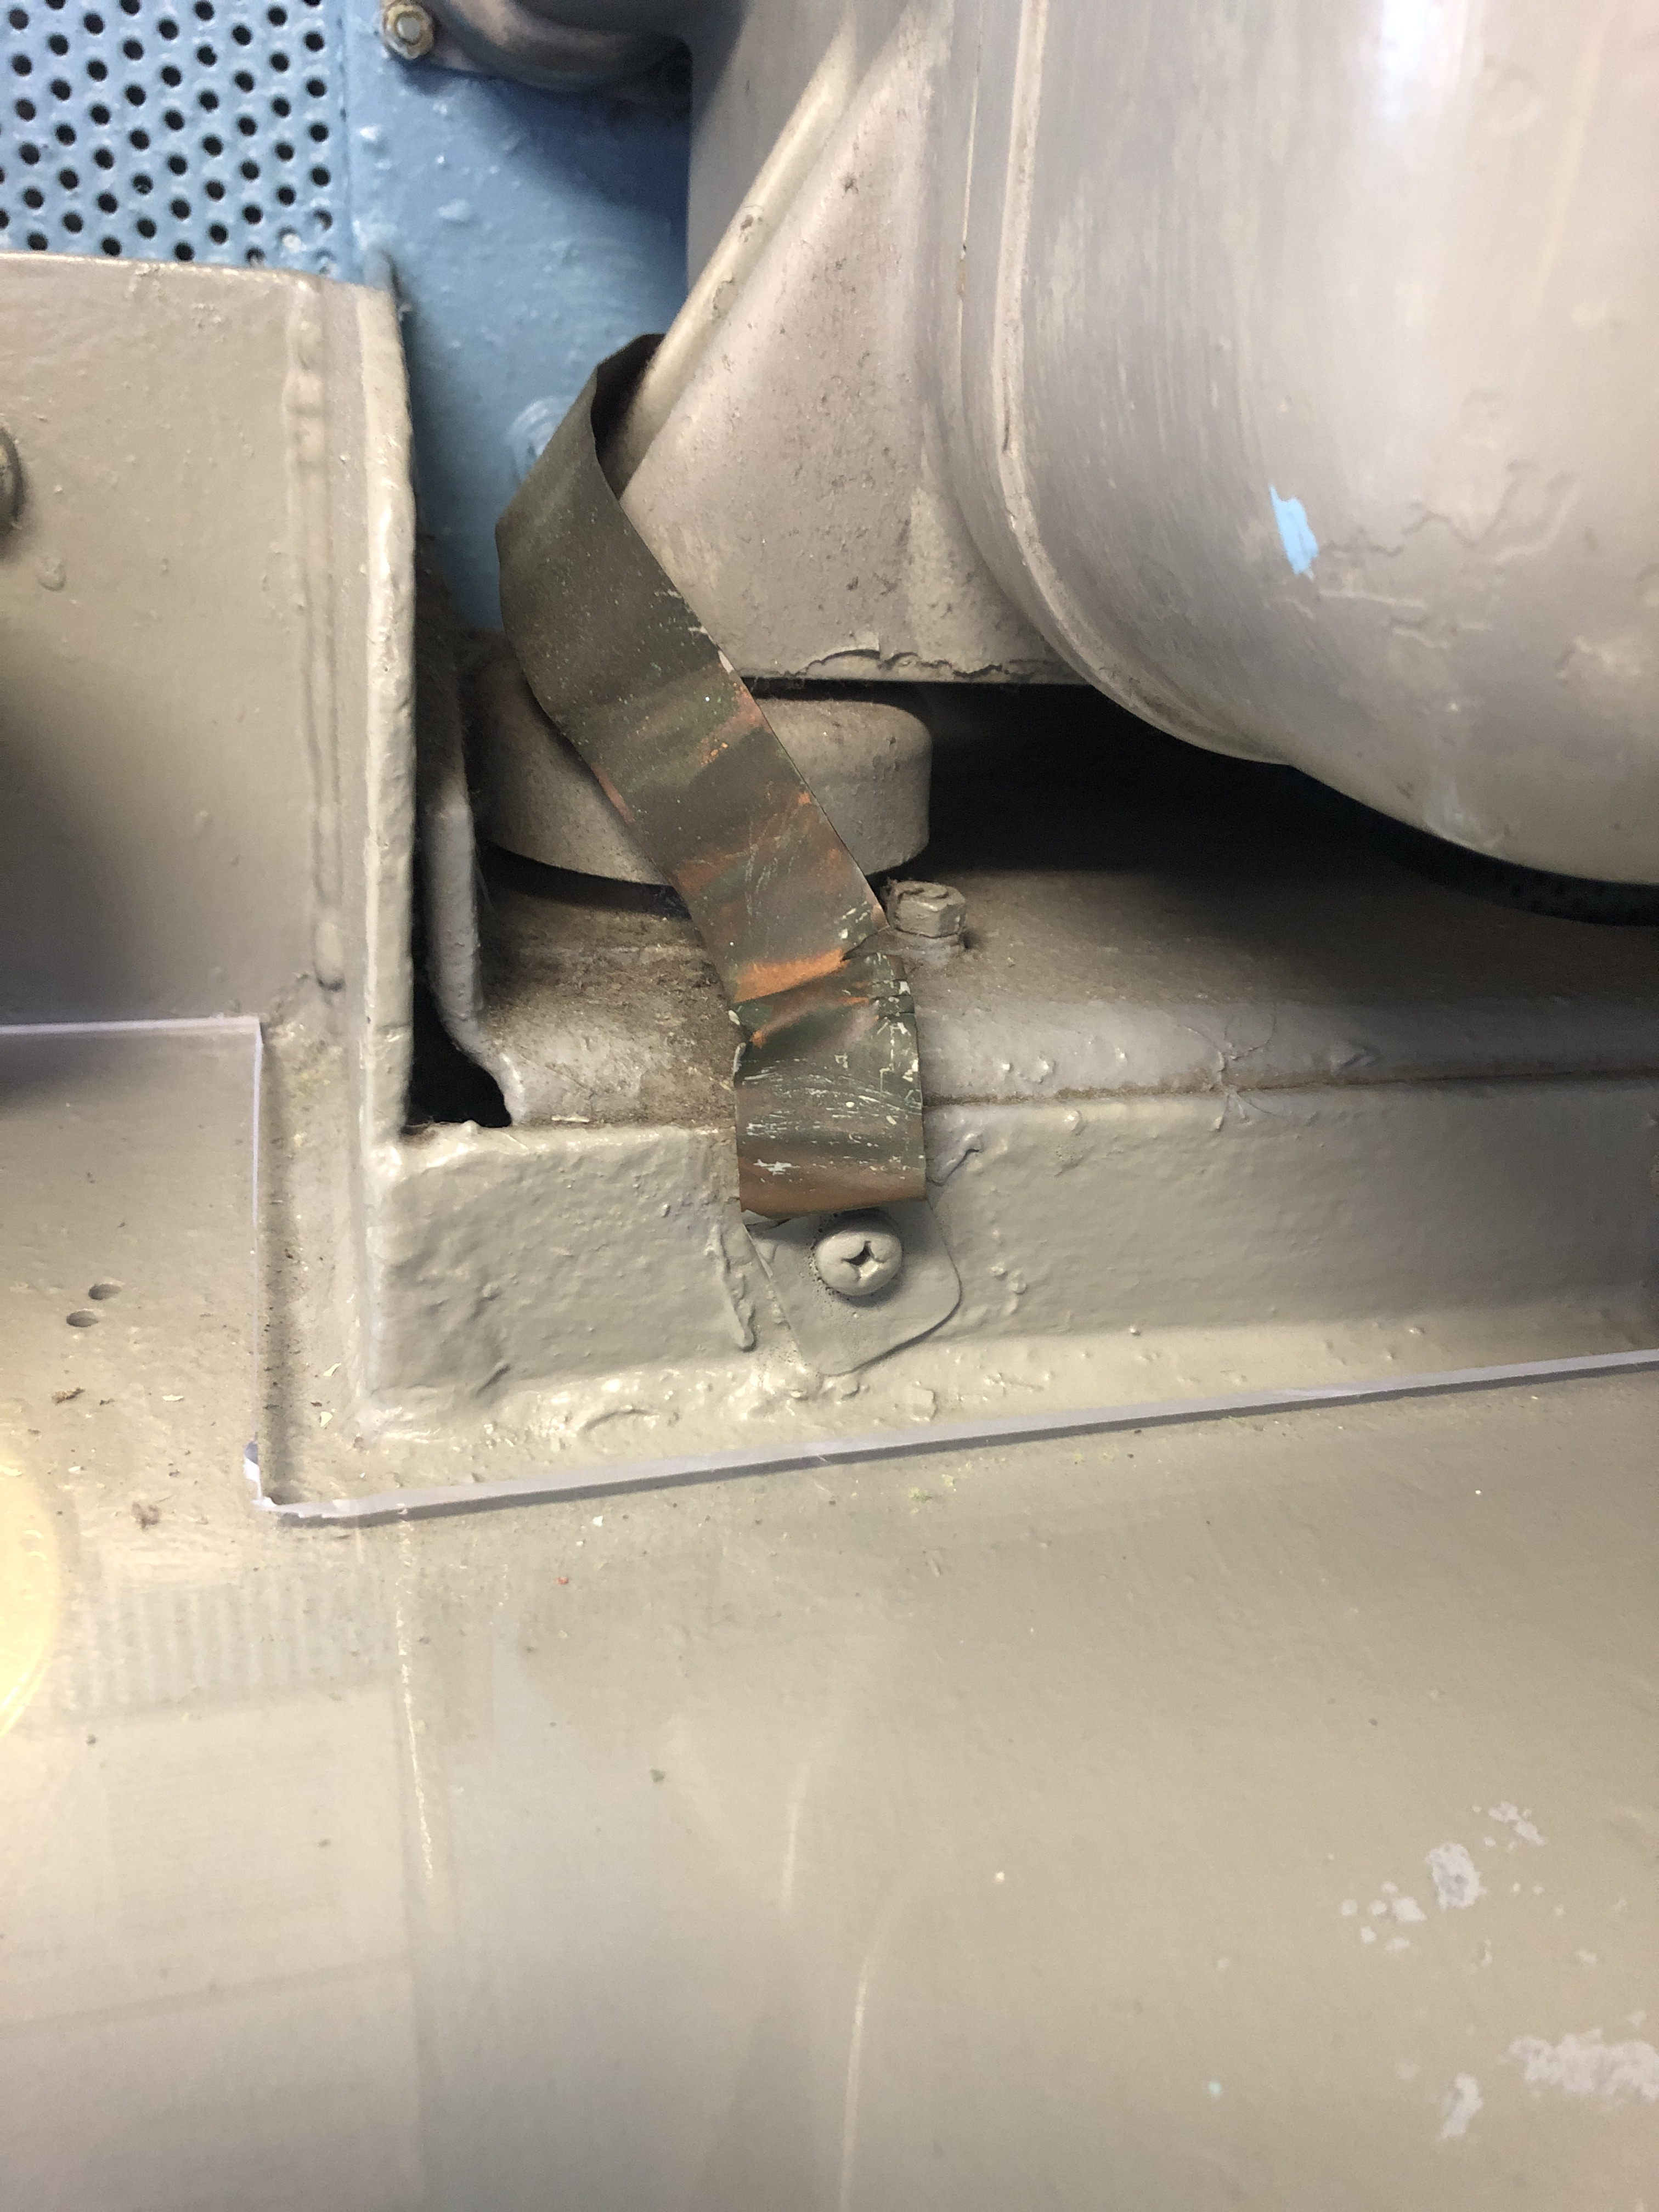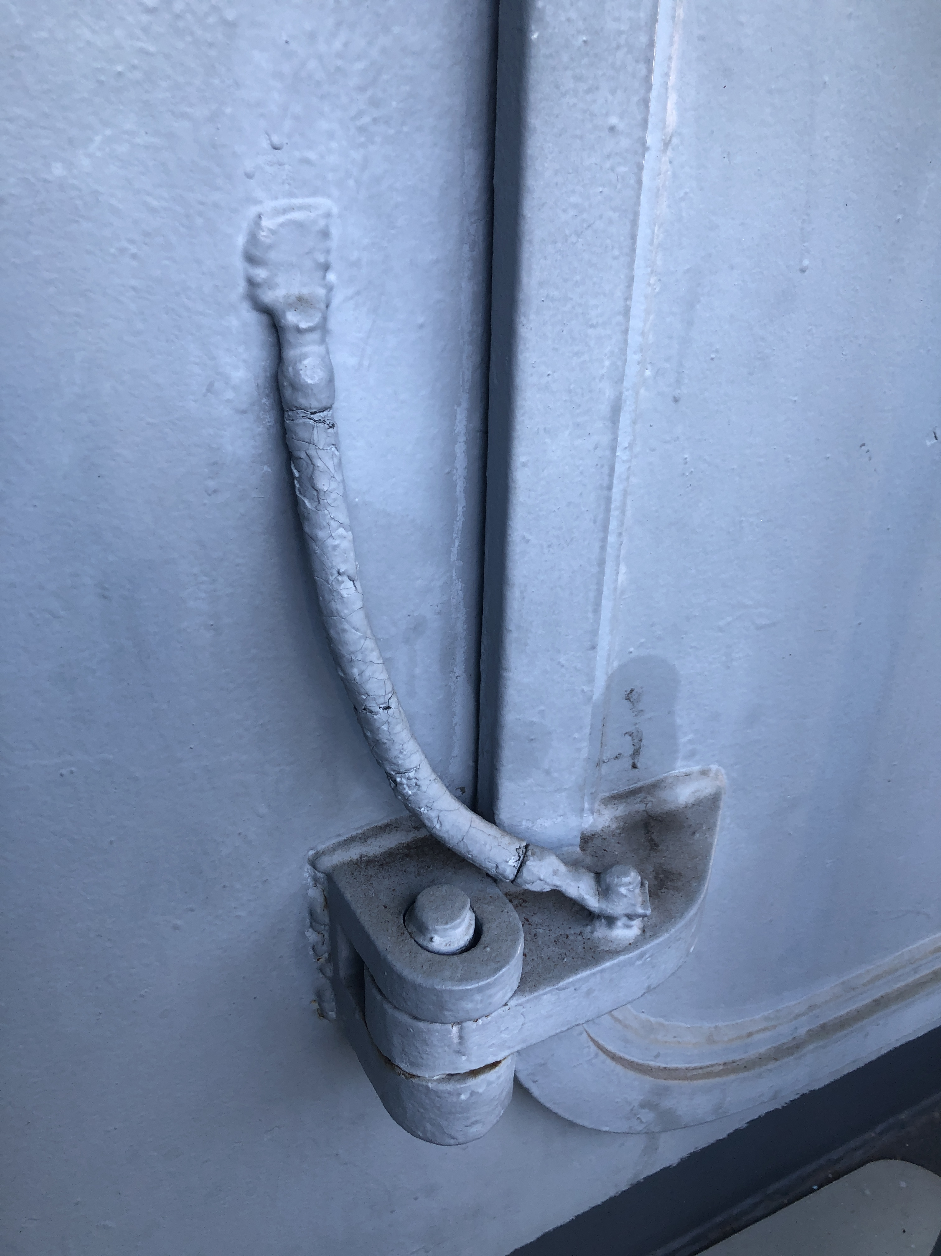
(a) (b)
Figure 16: Grounding (Bonding) straps (a) for equipment (b) for door (Photos by Norbert Doerry licensed CC BY 4.0)
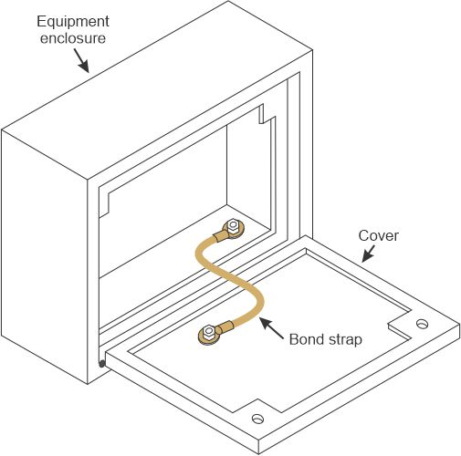
Figure 17: Bonding of equipment enclosure cover (Adapted from MIL-STD-2003-2)
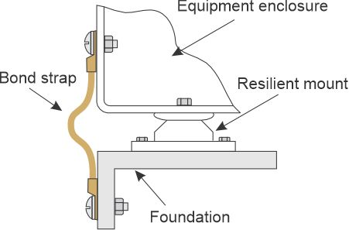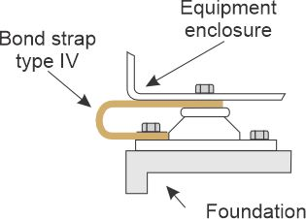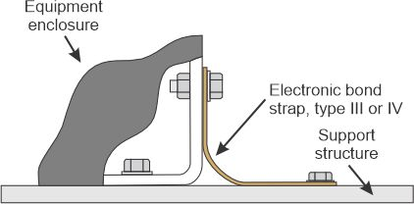
Figure 18: Bonding of equipment to ship’s structure (Adapted from MIL-STD-2003-2)
- Grounding of nonmetallic hulls
Traditional ships usually use the ship’s hull as part of the low-impedance path to ground. Nonmetallic hull ships do not have such an option. Instead, a grounding bus is employed to connect equipment to a copper grounding plate mounted on the exterior of the ship’s hull. IEEE Std. 45.1 provides the following guidance:
“On nonmetallic hull ships, ground plate(s) installed to provide an earth ground connection via contact with sea water should be installed to establish ground potential. The ground plate(s) should be installed at the lowest point of the structural hull, as close as possible to the vertical of the mast in a location that is fully immersed under all conditions of heel. Each ground plate should be a copper plate of area not less than 0.2 m2. A through bolt should be brazed to each ground plate to provide a connection point for installation of the cable grounding system ground plane. When the ship is removed from the water, an appropriate ground should be established and maintained.”
Figure 19 depicts a vessel with an ungrounded power system that employs a grounding plate for bonding / protective earth purposes. A system bonding junction connects all of the various bonding / protective earth conductors to the grounding plate. A separate grounding plate is provided for a lightning protection system.
Figure 20 depicts a vessel with a grounded electrical distribution system. The power system grounds are connected to a system grounding junction before being connected with the system bonding junction and the grounding plate. The system grounding and bonding junction should be as close to the grounding plate as is practical.
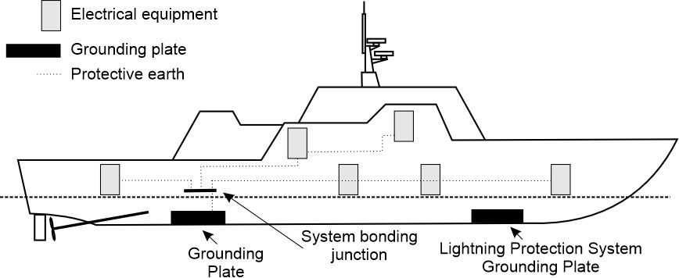
Figure 19: Bonding for ships with nonmetallic hulls and an ungrounded power distribution system
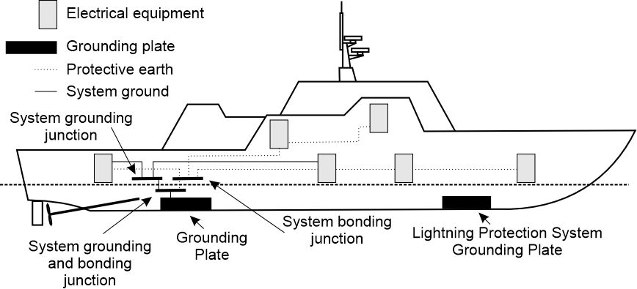
Figure 20: Bonding for ships with nonmetallic hulls and a grounded power distribution system
- References
IEEE Std 45.1 IEEE Recommended Practice for Electrical Installations on Shipboard--Design
IEEE Std 45.3 IEEE Recommended Practice for Electrical Installations on Shipboard--Systems Engineering
IEEE Std 3003.1 IEEE Recommended Practice for System Grounding of Industrial and Commercial Power Systems
MIL-STD-1310 Department of Defense Standard Practice – Shipboard Bonding, Grounding, and other techniques for electromagnetic compatibility, electromagnetic pulse (EMP) mitigation, and safety
MIL-STD-2003-2 Department of Defense Standard Practice – Electric Plant Installation Standard Methods for Surface Ships and Submarines (Equipment)
Doerry, Norbert, Mohammed M. Islam, John Prousalidis, Design of Shipboard Power System Grounding / Earthing , IEEE Press - Wiley, January 2025, ISBN-10 1119933080 ISBN-13 978-1119933083

